PULIC RESIGNATION
AND
DELIVERED TO PRESIDENT of WORLD PEACE COMMITTEE
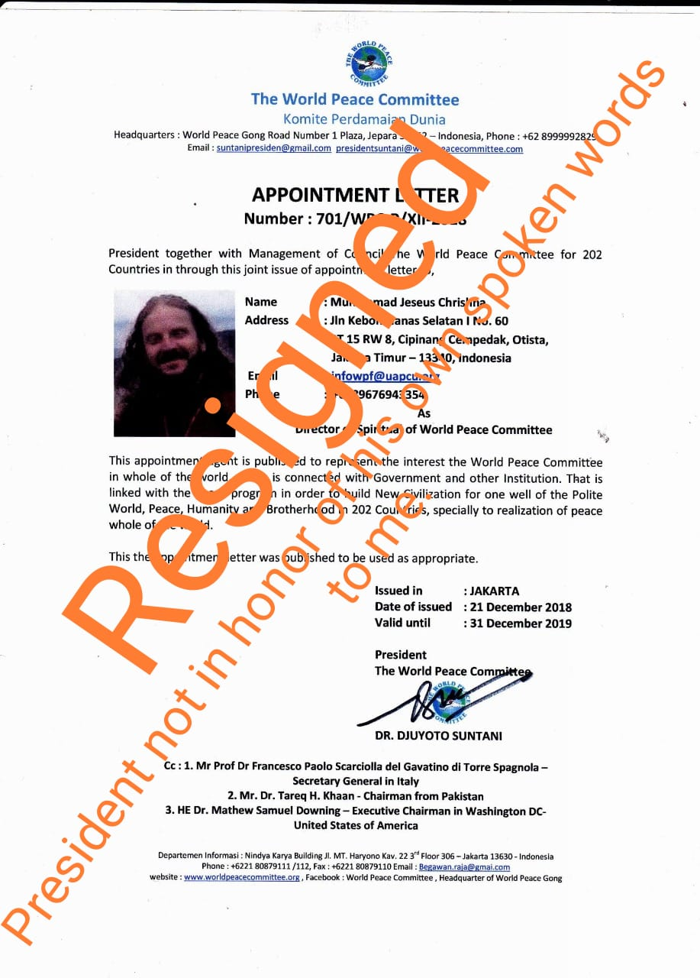
photo of APPOINTMENT RESIGNATION and Public Letter
Brother HE Djuyoto Suntani
Blessings on your Journey Sir,
And
In the way of the most merciful and compassionate,
I hope one day soon you will turn it around.
Accept the blessings.
Be a positive inspiration in the matter in front of and for humanity.
Note,
You were
Given Honorary Civil Certificates, of updated XXI Global leadership and XXI Citizenship, for you. Requiring you to complete the process,
Which included proving you deserved the Civil Certificates, as the only way to do so, study the material, and
Complete the Registry process.

The Universal State of Earth/United Nations Organization,
USE/UNO XXI Global Leadership Civil Certificate.
And The USE/UNO (UNESCO) Strategy Global Citizenship Fostering Program
The Civil Certificates.
Which you were quick to come meet me to receive.
Jumped when found out, would be awarded.
Also you were given,
The legal Standing
Universal Constitution of Earth.

Beloved brother,
If you had of even got past yourself, to read the only legal Standing Constitution of the whole Earth.
(Universal Constitution of the Earth)
Supreme law for all (including you) inhabitants of the world.
If researched, and in openness eyes of non closed mindedness, judging through self importance eyes,
But eyes of openness to truly working together.
To help save humanity from mentality you have showed.
Work together,
As the RENEWED United Nations is already at hand,
A new world ECONOMY is already at hand,
But you were in disregard of.

I can not force you, no wish nor will.
But through better understanding on your part, you may have made a wiser decision,
And may still yet make one?.
Openness,
The Universal one.

Beloved Brother if you had of read the documents, would have also known, (omong aja/lip service/given word-then break it) is not acceptable at 21st Century world Citizenship level/even more at Earth XXI - global Leadership level.
Then you may have honored your word to me,
Completed your Earth - XXI Global Leadership Upgrade,
Completed your Earth - XXI, Citizenship.
You may have understood the importance of the Unified Global Citizenship Program.
Goals of UNITED NATIONS and UNESCO,
The importance, of which YOU were Invited to be a leading figure of.
If all the above You may have better displayed a 21st century mentality. And not displayed the arrogance displayed when tried start another non needed crypto currency,

You may have
Understood the Global announcement of the New One World Economy currency, TERO.
By people studied and graduated in the matter of the Field, and thus you may so still agree (as USE/UNO doors are open,
Though note, you may have already agreed to meet the Earth Bank President.
With the first Universal Supranational Currency of the world, already available in account openings, in many nations of the world.
Currency above all currencies of the world, which all currencies naturally evolve into.
As more people enter the new era, XXI/21st Century,
Which other noble members of the Supreme Council of Humanity, such as United Nations past Secretary General and now Secretary General
Ban ki moon, and Antonio guterres, already campaign for, the required education to be taught all throughout the world,
Which also UNESCO, past Director and the Current director, Irina Bokova and Audrey Azoulay (all 4 - Earth - XXI Citizens) also campaign for, just as I humbly do, the required civil education to help all humanity in betterment, enter. This new era, with
21st century mentality,
This civil knowledge the basic required amount for every man, woman and child, become better citizens of their Countries but ultimately great WORLD CITIZENS.
USE/UNO (UNESCO) strategy global Citizenship fostering program,
Together with World Philosophical Forum,
www.wpf-unesco.org
We offer this new CIVILization Identity.

And thus, while a New World Economy needed,
It is already ready.

Sorry but we are not just free Social Certificate Givers. But life long learner's, the second you may think you know it all, is the second you close to becoming more.
Staying stuck may have its advantages for some, but ultimately, humanity will and needs to go beyond your limitations, will you?.

This is the whole World's Civil system upgrade sir, will not your committee honor such,
For the prosperous, peaceful, and safe future of humanity, and our planet we live on.
Please Read Your received Honorary proforma Civil Certifications,
Read them OUT LOUD to the WORLD,
And then try and give the same selfish reason,
You gave to me in Whatsapp yesterday morning. Try give it again.
To the eyes of the world, without manipulation,
Try! Please do.
You haven't completed the registry,
You may no longer act like the highest Authority on the planet,
And we invite the world to go beyond,
You may stay stuck if you wish.

I add,
You often claim to want build a new civilization.
And but sir, not even fully become it yourself, yet!.
It's not just about world peace gong, and your Committee, and your book,
Which even after I mentioned, about your non Philosophical Philosophy,
You still continue to hand the same version of the same book out to people. With the same Selfish desire written in it quote, (your philosophy is "too be the one and only") that's not Philosophy (philo Sophia/love of wisdom) not Philosophy Sir.
So it too needs updated,

No doubt it is simply through lack of understanding on your part,
And an outdated Individualistic mentality.

The other men tagged in this post too.
I chose you's all for good reason, out of honor and respect,
And in fact each one of yous were asked to work together at the highest intellectual level of humanity,
Agha Tareq of IN LOVE HUMANITY MISSION you received the same certificates.
Did you read the Basic Civil Knowledge document sent to you.?
World Peace Committee SECRETARY GENERAL apologized to me for both you’s/your actions.
And offered me military GOLD MEDAL of VALOR award from Italy.
Agha Tarek H Khan, you then blocked me on facebook to try hide this Scandal because you were tagged in it.
WHERE IS THE LOVE?
YOUS COULD REALIZE THIS WAS/IS OPPORTUNITY for yous to STEP UP - Become more, not run and hide.

These are/were not social awards,

But Highest World Status
And Higher World Status,
Civil, Complete with Civil duties.

Please, do not say you do not recognize good men, the likes of whom, like me also stood on Civil Right!,
For much great needed civil change in the world,
Civil reform, and also stood for injustice of selfishness, and dementia, in their era,
Martin Luther King was one,

So I implore yous, see the light,
Wisdom, reason, morality, justice and responsibility back to humanity.
Will you each step up, and act accordingly?

Peace, be upon you.

