What is the process of World citizen certification ?
1. Registration
2. Payment
3. Study the minimum knowledge of the world citizen
4. Give online exams
5. If you succeed in online exams then you receive the world citizenship certification

What are the benefits of having a world citizen civil certificate ? and the new U S E Civil Servant/XXI Civil Teachers Certification.

- TOP civil status of the Earth-XXI Citizen
2. By showing the Earth-XXI Citizen certificate to business and organizations you have more possibilities to get hired because of the high respectful world citizenship
3. Gain extra points for your CV
4. You can claim high positions in international organizations
5. Your name will be listed in the world citizens highest status list published in W.P.F WEBSITE U.S.E WEBSITE
6. Your part of a worldwide higher consciousness rise through world citizenship education
- Commission based Job Instantly.

Why World citizenship and or U S E Civil Servant/XXI Civil Teachers certification isn't expensive ?

The main idea of World Citizenship certificate is not the profit. The main idea and cause is to create world citizens of high consciousness level. World citizens are made to work together in order to save world from ignorance.

What are the official languages of lessons and exams ?

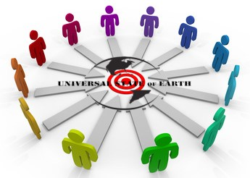
English and Greek

